**Foraging, fear and personality – a lesson from hummingbirds**

Katarzyna Wojczulanis-Jakubas1, Marcelo Araya-Salas2,3

1Department of Vertebrate Ecology and Zoology, University of Gdansk, Gdansk, Poland; biokwj@univ.gda.pl

2Laboratory of Ornithology, Cornell University, Ithaca, NY, USA. 3Escuela de Biología, Universidad de Costa Rica, San Pedro, San José, Costa Rica

**Abstract**

**Introduction**

It is now widely accepted that animal’s foraging strategy (i.e. resource exploitation) depends not only on the amount/distribution of available food resources (XXX) and animal motivation (marginal value theorem; Charnov XXX) but also predation pressure (Lime and Bednekoff, 1999; XXXX). The intensity of a prey vigilance increases with the level of risk predation (proportion/probability of predator presence), affecting prey foraging efficiency. The risk allocation hypothesis (XXX) imposes that prey will allocate the time to foraging inversely proportionately to the predation pressure. In the light of such a time trade-off, a fixed foraging strategy is expected to evolve, with an adaptive behavioural norm in a given food-resources – predation landscape. Indeed, numerous studies provide evidence on existence of such a foraging strategy (XXX). However, numerous studies also show high inter-individual variation in the foraging strategy.

Recently, animals personality has been pointed out as an important source of the inter-individual variation in performance of any strategy, including foraging decisions (XXXX). Personality (also called…) is a behavioural response of an individual to given environmental challenge, which is consistent for an individual over the time and context (XXX). There are five main axes along which the personality is considered: exploration, risk-aversion, arousal, aggression and sociality (XXX). Within a species/population individuals usually represent a full continuum of given trait, with two polar opposite phenotypes (eg. very bold vs very shy individuals) and various intermediate forms in between. Importantly, fitness advantages of the contrasting behavioural phenotypes differ in various context, sometimes dramatically. For example, boldness may favour individual in inter-individual competition but it may be also disadvantageous in conditions of high predation pressure (XXX).

How behavioural variability is maintained in the population if the fitness consequences of given trait vary across the context remains open question. The question is particularly intriguing in the context of the risk allocation hypothesis where, in given conditions of food resources availability and predation risk, only a fixed behaviour gives the highest fitness. This apparent paradox can be solved by examining fitness consequences of various behavioural profiles in foraging, in various conditions of predation risk. Here, we investigated fitness consequences (expressed by foraging efficiency) of behavioural performance in three personality-related areas: exploration (number of feeders used during the foraging visit), risk-avoidance (latency to approach the feeder to forage), and arousal (amount of movement during the foraging visit), in conditions of low- and high-risk predation in a wild ranging hummingbirds, long-billed hermits (LBH, *Phaethornis longirostris*).

Hummingbirds, and that includes LBHs, are known for their extreme metabolism, and high need for energy intake makes them constantly motivated to forage, as a longer period of food deprivation may lead to starvation (XXX). For this reason, hummingbirds are expected to forage regardless of the risk level (so called paradox of RAH, XXX). On the other hand, however, hummingbirds are particularly vulnerable to predation. Although they rather do not have a specialized predator, they are often taken opportunistically by a wide range of predators (including invertebrates like mantis, XXX). That imposes a great predation risk, and is expected to favour evolution of strong risk-aversion. Thus, a trade-off between foraging and avoiding predation is expected to be particularly pronounced in hummingbirds. This obviously hinders *a priori* prediction for birds response to conditions of low- and high- risk predation. Nevertheless, we considered three hypothesizes for behavioural traits. First, we expected that foraging efficiency will be positively correlated with the explorative behaviour. This is because during foraging, explorative individuals often being bold in terms of risk-aversion (XXX), are likely to allocate less time in other activities than foraging, thus their foraging should be more efficient, compared to individuals that need more time to make a decision about onset of the foraging. Second, for the other two behavioural traits – risk-avoidance and arousal - we expected a negative relationship with foraging efficiency, as these traits potentially increase the time allocation for activities not related with foraging per se, so decreases foraging efficiency per unit of time. Finally, we for each trait, as it can be considered as a proxy for personality, we expected repeatable performance of individuals, regardless of the predation context.

**Material and methods**

*Fieldwork.* We carried out the study at the area of one of LBH leks in La Selva Biological Station, Costa Rica (10 o23’ N, 84o10’ W) between May and June 2015. Owing to another project on LBH being carried out the same time, local birds were already individually marked [Fig. 1; foam tags of unique colour combinations, attached to bird back and breast with nontoxic eyelash glue, see Araya-Salas et al. 2018 for details] and habituated to use feeders. Of the XX birds marked at the study lek (XX territorials and XX floaters or females), 12 individuals regularly used feeders utilized in the present study (located at XX distance from the closest lek border) and so were tested in the experiment.

**Fig. 1** Long billed hermit (LBH) marked with a foam tag of unique color-combination. Photo credit: XXXX

We used three one-flower feeders for the experimental set up, arranging them in a line, separated by ca 10 cm distance from each other (Fig. 2). The experiment consisted of two phases – control and experimental, both performed at the same day, with the control being directly followed by the experimental phase. The experimental phase started at the moment when all the focal individuals have been recorded at the feeder for the control conditions, and lasted until all of them visited the feeder again in the experimental conditions. Since focal individuals visited feeders regularly, appearing at the site on average XX times per hour, we were able to complete the two phases within ca XX hours. During both phases of the experiment the three feeders were filled up with ~ 30% sugar-water and birds were allowed to forage on the nectar spontaneously, while their behaviour at feeders site were recorded by human observer and a commercial camera (XX). The only difference between the control and experimental phase were a threat model attached to feeders during the experimental phase. For the threat model, we used specimens of the bull-headed ant (XXX; found dead in the forest). Although the ant is not a predator of hummingbirds (including LBH), the ant-bird encounter imposes potential danger for the bird in the form of being bitten. Indeed, an average birds response was as an expected for a potential treat (see results). We performed total of four complete experimental sessions (control and experiment) within ca two weeks.

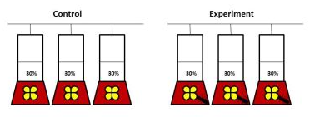

**Fig. 2**. Feeders set up

We first screened video recordings with VLC software (XXXX), to locate and cut out video fragments with foraging visits of all focal birds. As a foraging visit we considered birds’ visit at the feeder area when it inserted the bill into a feeder at least once. For each visit (both at control and experimental phase) we established several crucial time-points (white and black circles on Fig. 3), with 0.1 seconds precision, using Cowlog software. Based on the time-points we calculated duration of events such as: latency to forage (the interval between appearance in the feeder area (usually hovering in front of the feeder) and the onset of foraging, i.e. distance a-b on Fig. 3); foraging interval/s (e.g. distance b-c, Fig. 3; on average XX events); foraging break/s (e.g. distance c-d, Fig. 3; on average XX events); total foraging (distance b-e, Fig. 3) and total foraging visit (distance a-e, Fig. 3). For each visit we also noted which and how many times each of the three feeders were used by the focal bird.

To further analyse birds behaviour we calculated several parameters (see Supplement materials) and selected those which the represented the behavioural traits that we could interpret as exploration and risk-avoidance, and also exhibited high inter-individual variation. As a proxy for **explorative behaviour** we utilized a **standardized number of feeders** - totalnumber of various feeders (i.e. 1-3 feeders) used during the foraging visit divided by the total foraging duration. As a proxy for **risk-avoidance** we utilized **latency to approach the feeder** – as defined above (latency to forage, distance a-b on Fig. 3). For both the parameters, we assumed that the higher the value, the stronger is the exhibited behaviour.

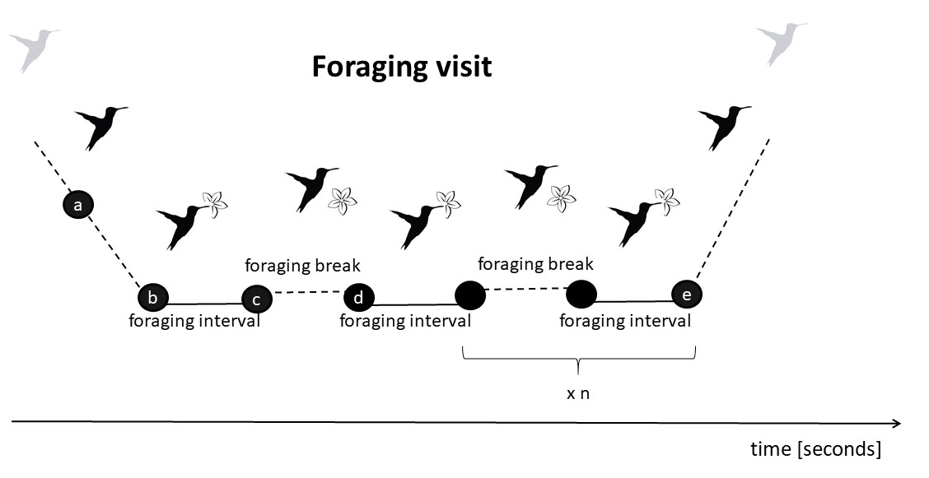

**Fig. 3.** Components of the foraging visit.

As **arousal** we considered a total amount/range of movements at the feeder recorded during the total foraging time (distance b-e on Fig. 3), standardized by the number of feeder changes. For that we first processed the video recordings using Tracker software (XXX), which allowed to establish Cartesian coordinates of a bird position for each video frame. Then, we calculated coefficient of variance of bird movements based on the formula: sqrt((xj - xi)2 + (yj - yi)2), where xi,j and yi,j are Cartesian coordinates of the bird position in a focal i and previous j video frame. Since the birds movements could be biased by explorative behaviour, we standardized this coefficient dividing it by the number of feeder changes at given visit. We expected that the higher value, the higher arousal.

Finally, we calculated **foraging efficiency**, which was the ratio of total duration of foraging (sum of all feeding intervals) and duration of the foraging visit.

*Data analysis.*

We compared foraging efficiency between control and experimental conditions using linear mixed models (LMM), with treatment as a fixed factor and bird identity as a random factor. To test an effect of individual performance, we compared model with and without bird identity (Chisq test). For examining repeatability of individual’s behaviours we also applied modelling approach (Nakagawa), using XX package (XXX). Then, we analysed foraging efficiency in regard to each behaviour separately, again using modelling approach (LMM), with treatment being a fixed factor and bird identity as a random factor.

**Results**

Foraging efficiency was strongly affected by experimental treatment (LMM, estimate = -0.11, SE = 0.03, t = -3.91, df = 188.17, P < 0.001), in general being lower in experimental conditions (Fig 4A). There were also individual differences in foraging efficiency in response to the treatment (Chisq = 17.06, df = 1, P < 0.001), with some individuals being more efficient in control conditions while others exhibiting a reverse pattern during the experimental treatment; in one case only foraging efficiency was similar in both control and experimental conditions (Fig. 4B).

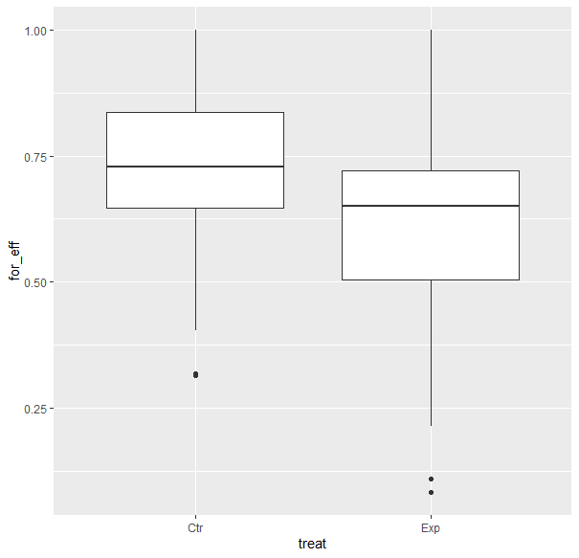

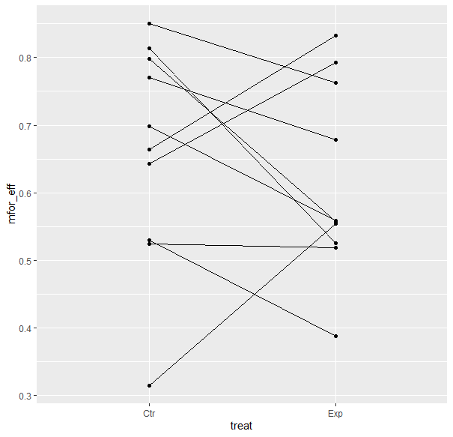

**Figure 4.** Average foraging efficiency of each focal individual in the context of low- and high-risk predation.

**Repeatability** of behaviours was moderate and significant for exploration (R = 0.28, CI = [0.044, 0.475]; LRT: P < 0.001) and risk-avoidance (R = 0.269; CI = [0.064, 0.454], P < 0.001), and very low for the arousal (R = 0.007, CI =[0, 0.09; LRT: P ~ 1].

**The explorative behaviour** (i.e. number of feeders used during the foraging visit) slightly increased in response to a threat (LMM, estimate = 0.09, SE = 0.04, t = 2.12, df = 186.57, P < 0.04). The behaviour was related to foraging efficiency (LMM, estimate = 0.47, SE = 0.18, t = 2.53, df = 192.95, p = 0.01), however, direction of the relationship was clearly condition-dependent (as indicated by the treatment x explorative behaviour interaction, LMM, t = -5.72 , df = 188.5, p < 0.001). In undisturbed conditions, the relationship was positive (LMM, estimate = 0.50, SE = 0.16, t = 3.18, df = 139.21, P = 0.002), while in threatening conditions foraging efficiency decreased with exploration index (LMM, estimate = -0.93, SE = 0.21, t = -4.36, df = 49.87, P < 0.001 Fig. 5).

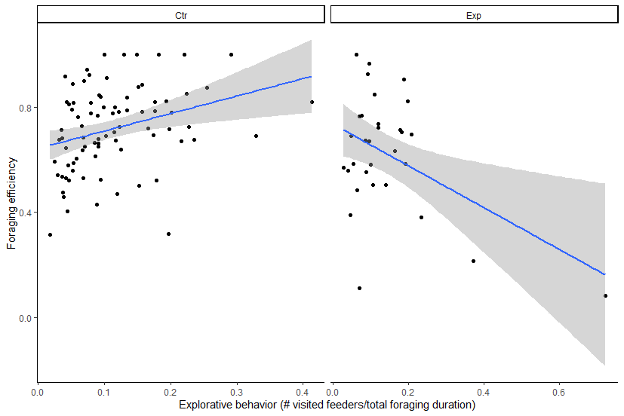

**Fig. 5**

Latency to approach a feeder (**risk-avoidance**) was also affected by experimental treatment, being longer in the threating conditions (LMM, estimate = -0.13, SE = 0.04, t = -3.16, df = 191.329588, P = 0.002; Fig. 6). Overall, and independently on conditions, foraging efficiency was lower when high risk-avoidance was exhibited (LMM, estimate = -0.02, SE = 0.01, t = -2.19 , df = 191.99, P = 0.03; interaction of latency and treatment: estimate = 0.02, SE = 0.01, t = 1.53, df = 191.99, P = 0.13; Fig. 6).

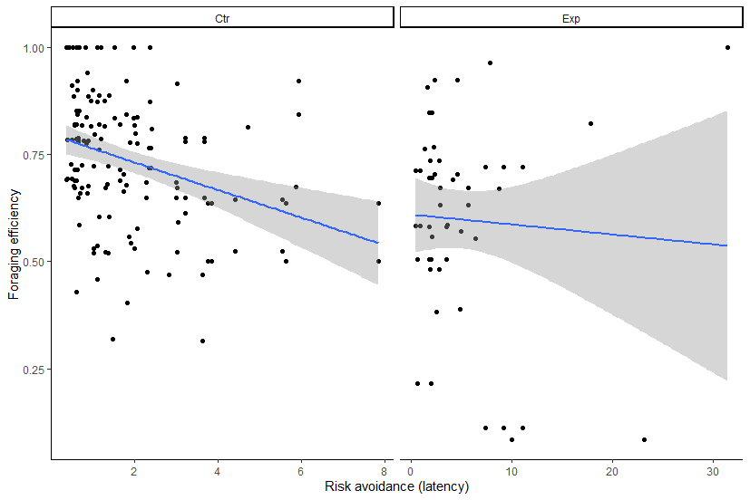

**Fig.6**

The range of birds movements (**arousal**) increased in response to a threat (LMM, estimate = -0.33, SE = 0.05, t = -6.13, df = 188.71, P < 0.001). The arousal was positively related to foraging efficiency (LMM, estimate = 0.04, SE = 0.01, t = 3.85, df = 188.55, P < 0.001), and in the experimental conditions the relationship was the stronger (as indicated by the treatment x explorative behaviour interaction, LMM, t = 5.23, df = 188.36, p < 0.001; Fig. 7).

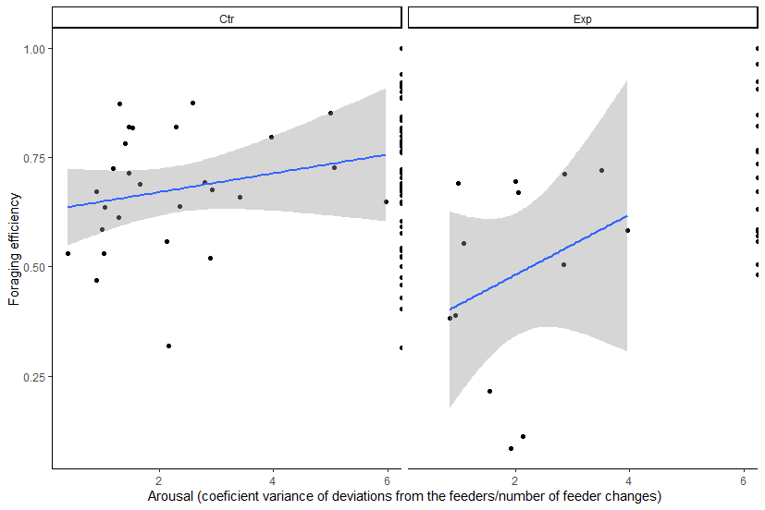

**Fig. 7**

**Discussion**

According to balancing selection theory, frequency-dependent selection could maintain variation in trait values (Dall et al. 2004; Hurst 2009). But what also can maintain variation is differentiated effect of the behaviour in relation to the context!

**Acknowledgments**

**References**